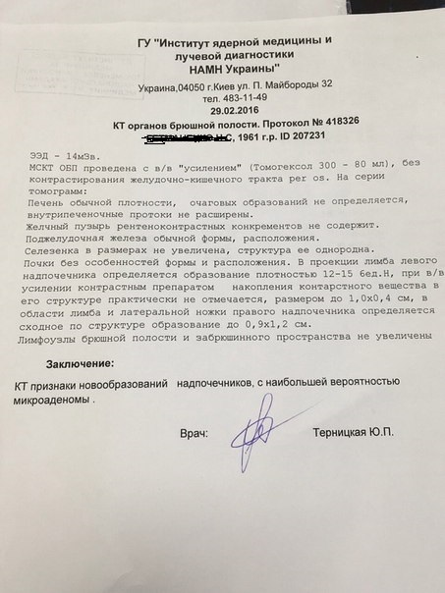

СT of the abdominal organs
Protocol № 418326
Effective dose - 14 mSv
MSCT of the abdominal organs conducted with intravenous enhancement (TOMOHEXOL 300 - 80 ml), without contrasting of GIT per os.
On the tomograms:
Normal liver density, focal masses are not detected, intrahepatic ducts are not extended.
The gallbladder does not contain radiopaque stones. The pancreas is of usual form and location.
The spleen is not enlarged and of homogenous structure.
The kidneys are of usual form and position. Within the limb projection of the left adrenal gland there is a formation (12-15 HU density and to 1.0 X 0.4 cm in size). With IV enhancement by contrast media there is almost no accumulation of contrast agent in its structure. There is a formation similar in structure in the area of a lateral limb of the right adrenal gland to 0.9 – 1.2 cm.
The lymph nodes of the abdominal cavity and retroperitoneal space are not enlarged.
The conclusion: CT signs of adrenal gland tumors with the huge possibility of microadenoma.

